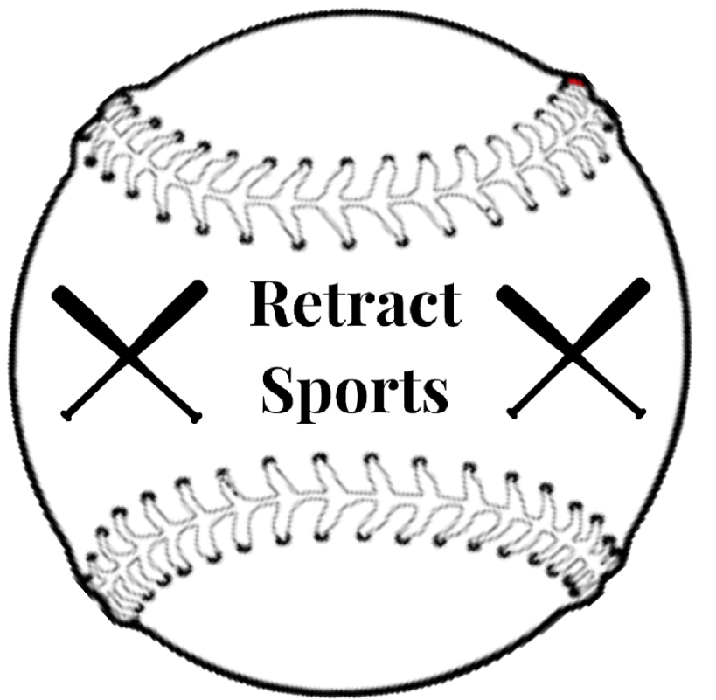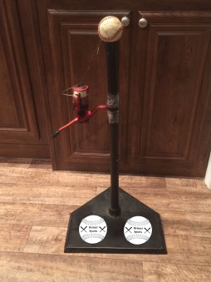

**This is a new kind of batting tee that lets you roll the ball back to you after you hit it!**

**Contact Information:**

**Address: 45 Gable Ln. Abbeville S.C.**

**Phone Number: (843)864-8046**

**Email: RetractSports@gmail.com**

**Retract-A-Ball**

**“The ball that’s always rolling back!”**